[Type the company name]
Biomechanics of the Throwing Shoulder
[Type the document subtitle]
Brian Axtell and Jordan Woods
5/1/2009

[Type the abstract of the document here. The abstract is typically a short summary of the contents of the document. Type the abstract of the document here. The abstract is typically a short summary of the contents of the document.]

The Biomechanics of the Throwing Shoulder
There are many different actions and movements that go on during any particular sporting event but there is one movement that seems to keep adapting and keep changing but at the root, it all breaks down to the same thing. Throwing an object takes lots of strength, flexibility and timing, and without anyone of these particular skills an athlete is putting themselves at risk for injury. The throwing action can be a dangerous movement if it is not performed correctly because of how strenuous the movement is on the joint its self. “Throwing a baseball is one of the fastest and most violent maneuvers that any joint in the body is subjected to. The violent and rapid motion places numerous structures in the shoulder at risk for injury” (Rush). This motion, though strenuous, can be done properly without hurting or creating a whole lot of stress on the shoulder joint itself by practicing proper techniques and making sure the correct muscles are well prepared. A good throwing motion breaks all the way down to proper mechanics. If an athlete can complete the throwing motion correctly, taking as much stress off of the shoulder joint itself, then the athlete will be able to be successful using the throwing motion. This paper will not only breakdown the movement of the throwing motion but also discusses injury prevention when it comes to throwing. The Rush University Medical Center says that “Prevention of injury is the key to a long career” (Rush). Once an athlete understands proper mechanics and training habits, then they will be able to complete this effective motion with hardly any effort and no pain.
The shoulder has the most range of motion, than any other joint located on the body. There are many different kinds of movement that this joint can perform; arm abduction, adduction among the shoulder, arm flexion and arm extension, arm hyperextension and arm hyper flexion, arm external and internal rotation with medial and lateral rotation. The last but the most known movement of the shoulder joint is cicumduction. Cicumduction is a circular movement, which combines flexion, extension, abduction, and adduction so that the movement of the body-part describes a cone shape. The distal end of the limb moves in a circle, while the proximal end remains stationary (Circumduction).
You can see all of the movements depicted by the pictures below.
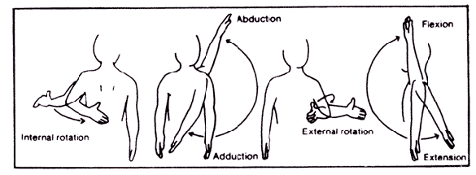

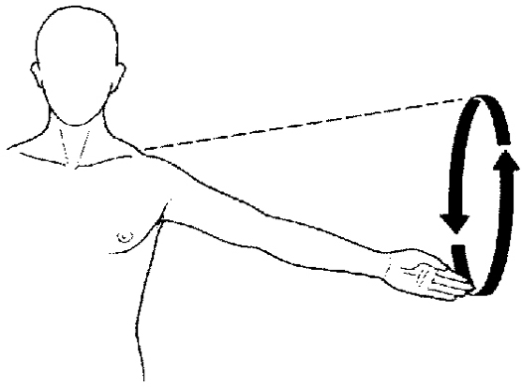

In order to understand how the shoulder works one must first look at the anatomy of the shoulder to get an idea of how it actually works. The shoulder joint is made up of only two main bones, the Scapula (or the shoulder blade) and the Humerous. The Humerous has a round head on the most superior end that fits into the cavity that is created by the Scapula. “The end of the scapula, called the glenoid, meets the head of the humerus to form a glenohumeral cavity that acts as a flexible ball-and-socket joint” (Anatomy). This ball-and-socket joint is pretty incredible in how much movement it allows the humerous to have. The head of the Humerus also has articular cartilage covering the head to help reduce the amount of friction there is inside the cavity. Articular cartilage can also be found in the knee serving the same purpose of lubrication. There are also a couple processes, or bone stubs, that project out past the cavity itself. These processes are called the Acromion process and the Coranoid process. These processes help shape the shoulder joint and also help to protect the joint from any force that should be applied to the outer part of the joint. When it comes to the bones of the shoulder, it is pretty simple, but that is the reason for the amount of motion this joint has.
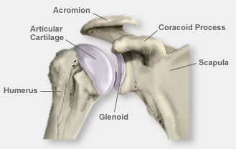
After understanding the bones of the shoulder and how the shoulder is made up, we can now discuss the muscles of the shoulder. Starting as deep as possible, the first thing that holds the shoulder in place and helps it move is called the rotator cuff. The rotator cuff is a series of four muscles that surround the head of the humerus holding it into the capsule and producing all the movements the shoulder makes. The first muscle is Supraspinatus. The name of this one gives away the location of the origination of this muscle. “The Supraspinatus muscle originates on the Supraspinous fossa of the scapula and inserts on the proximal facet of the greater tuberosity of the humerus” (Behnke). Basically this muscle starts on the top of the scapula, goes over the top of the head holding the head into the cavity, and attaches to the outside of the humerous just below the head. This is a very important muscle because, “it is considered the primary initiator of abduction until approximately 30 degrees of abduction” (Behnke). This muscle plays a key role in the movement of the shoulder as well as keeping the shoulder joint together.
The next muscle of the rotator cuff is called Infraspinatus. Looking at the name of this muscle you can already tell that this muscles name gives away the origination as well. This muscle originates from the infraspinatus fossa of the scapula, just below the spine of the scapula. The infraspinatus muscle insertion is shared by the Supraspinatus, being the greater tuberosity. “Contraction of the infraspinatus muscle produces external rotation and extension of the shoulder joint” (Behnke). This muscle is responsible also for holding the head of the humerous into the cavity by pulling from behind the head of the humerous. Without this muscle the head of the humerous would slip out to the front and not allow the shoulder to function properly. The next muscle is the teres minor and its insertion is located at the crest of the lesser tuberosity of the humerus. It helps with extension, inward rotation, and adduction. The last muscle of the rotator cuff is the subscapularis, it inserts at the lesser tubercle of the humerus. Its action is extension and inward rotation of the shoulder joint. Other muscles that help to move with the shoulder joint are the deltoid, the coracobrachialis, teres major, latissimus dorsi, and pectoralis major. The deltoid is located from the inferior edge of the scapular spine to the anterior lateral third of the clavicle. This muscle helps with abduction, flexion, internal rotation, horizontal adduction, outward rotation, and extension. The teres major is found at the lower 1/3 of the axillary border of the scapula/inferior angle of the scapula. It helps with adduction, extension, and inward rotation. The latissimus dorsi is a large muscle that can be found at the spines of the 6 thoracic and lower lumbar vertebrae, the posterior surface of the sacrum, the posterior aspect of the illium, inferior angle of the scapula, and the lower 3-4 ribs. The last muscle of the shoulder joint is the pectoralis major. It can be found at the medial half of the anterior surface of the clavicle, and the anterior surface of the costal cartilage of first six ribs, adjacent portion of the sternum. All of these muscles work together to give the arm the momentum needed to complete the throwing motion.
Now that it is clear how the shoulder is made up, describing the throwing motion can be understood. The throwing motion can be described as an isotonic eccentric contraction. Starting at the cocked position, where the throwing arm muscles really begin to start working, the Serratus anterior and the Subscapularis muscles are the main muscles in starting the arm motion forward. Once the Serratus and the Subscapularis starts the arm forward, the Trapezius, Rhomboids, Posterior Deltoid, Triceps and the Latissiums Dorsi all begin flexing accelerationg the arm forward. The most force is put on the Subscapularis muscle at this time. The muscles in the forearm, flexor Carpi Radialis, and Flexor Carpi Ulnaris, also are flexing in the acceleration phase increasing velocity. Once the extensors in the arm release the ball then the deceleration phase begins. The main muscle used in the deceleration phase is the Teres Minor but is assisted by the trapezius, posterior deltoid, subscapularis, the Latissimus Dorsi, and the Supinator of the forearm. After the arm decelerates then the muscles relax. Looking at this breakdown, there are muscles that are used all the way through the motion, like the subscapularis and the deltoid. This movement creates a lot of stress on these muscles and can create lots of injury if not completed correctly. (Shoulder)
Injuries to the throwing shoulder are a very common occurrence and the proper steps should be taken to prevent these injuries from happening. “As the kinetic chain is fundamental to the throwing motion, a training program that strengthens all elements of this chain and links them smoothly is very important” (Injuries). All of the little muscles that are used in the act of throwing do not get used on a daily basis so they will not be condition to exert as much for unless trained too. Stretching is very important also. Proper stretching of the shoulder area will help to loosen up the muscles and allow the shoulder joint to travel in a full range of motion without much resistance. Strengthening the rotator cuff is very important. Those four muscles are under a lot of load when the arm begins to accelerate forward and need to be strong to be able to resist abuse over and over.
The throwing motion is a very violent motion for the shoulder and honestly the overhand throwing motion is not very good on the arm. With the proper training and conditioning an athlete can train their muscles and strengthen the correct muscles to help to prevent injury from happening. If an athlete that relies on their arm does not take the correct precarious, the injuries can be painful and career ending.

